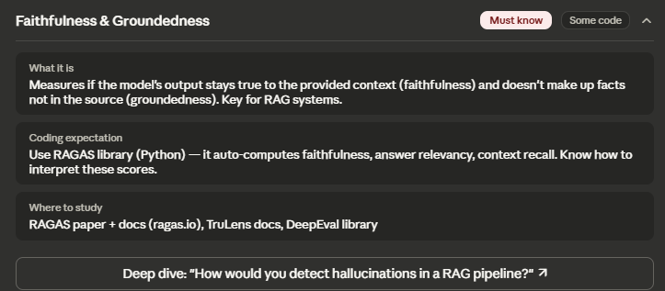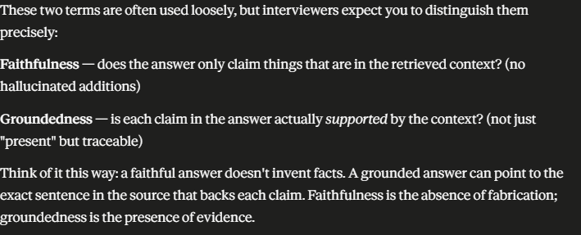
ROUGE
Recall Oriented Understudy for Gisting Evaluation – It measures how much of the reference content appears in the generated output. Instead of focusing on the matching phrases exactly, Rouge focuses on recall. That is how much, of the important info is captured.
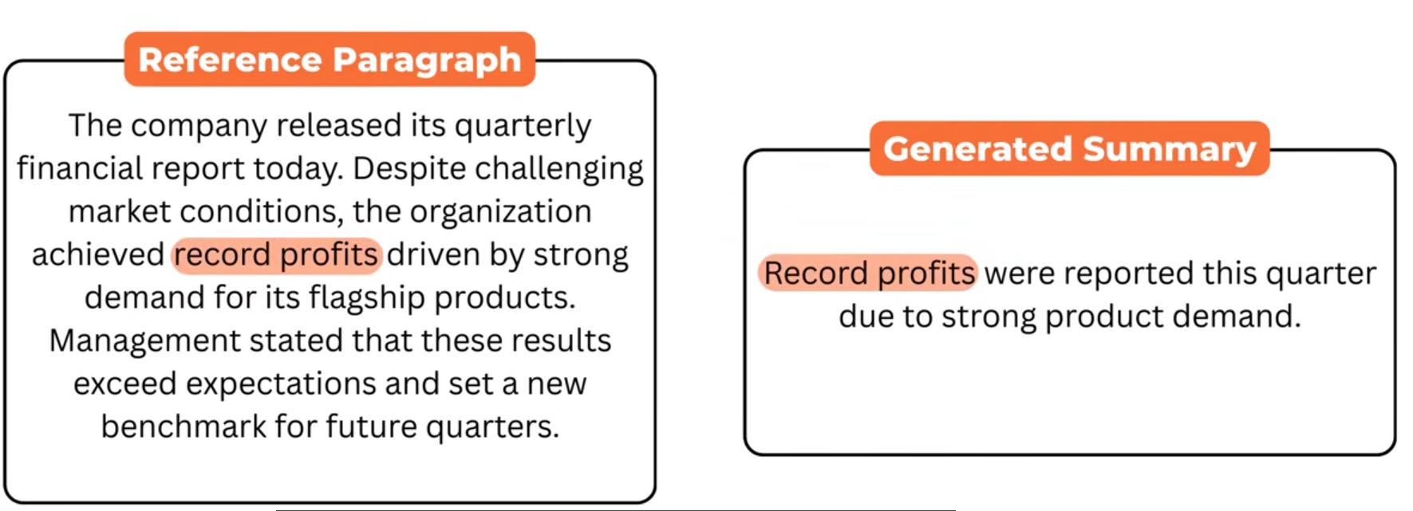
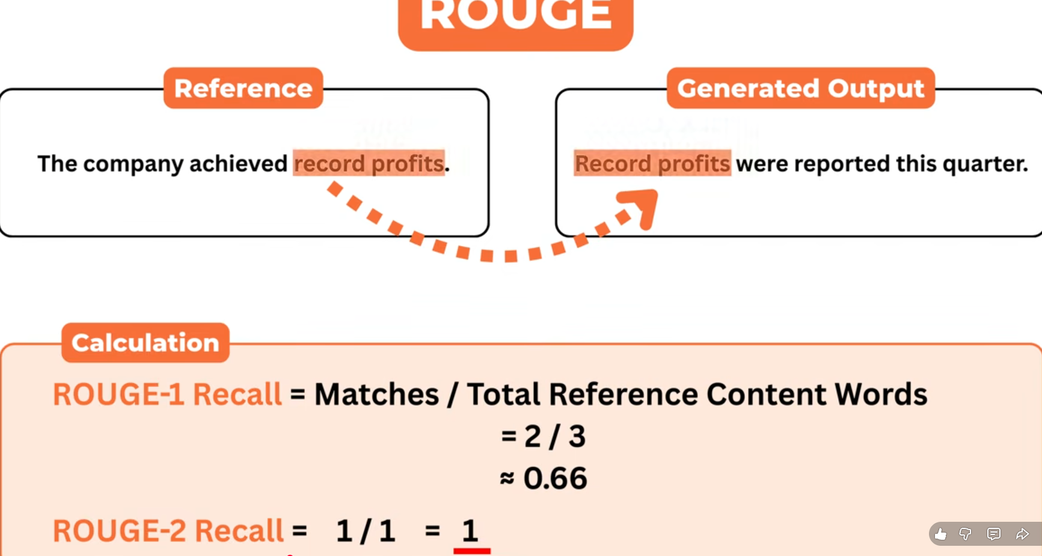

F1 Score measures how many important elements in the generated answer matches the reference. F1 is ideal for factual correctness. It works using precision and recall. Then combines them into a single number. Precision tells how many of the predicted items are correct. Recall tells us how many of the correct items were captured. F1 is the harmonic mean of the two giving a balanced score.
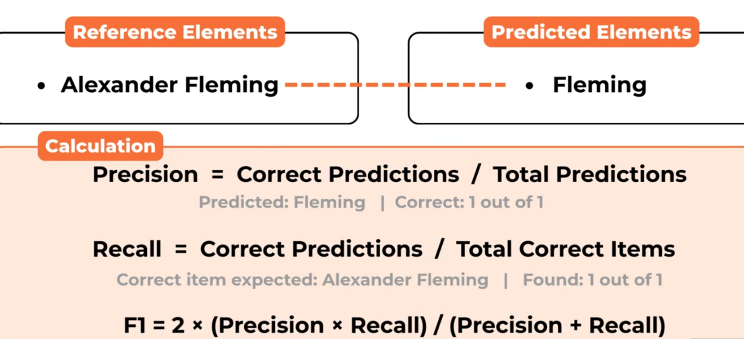

For RAG we need new metrics we cant rely on above. 1. Context Precision 2. Faithfulness 3. Context Recall 4. Answer Relevance

- Context Precision – It measures how much of the retrieved context is relevant to the question. If the system retrieves 5 chunks and only two out of them are useful, the precision is 2/5=0.4
Higher precision means lesser noise. 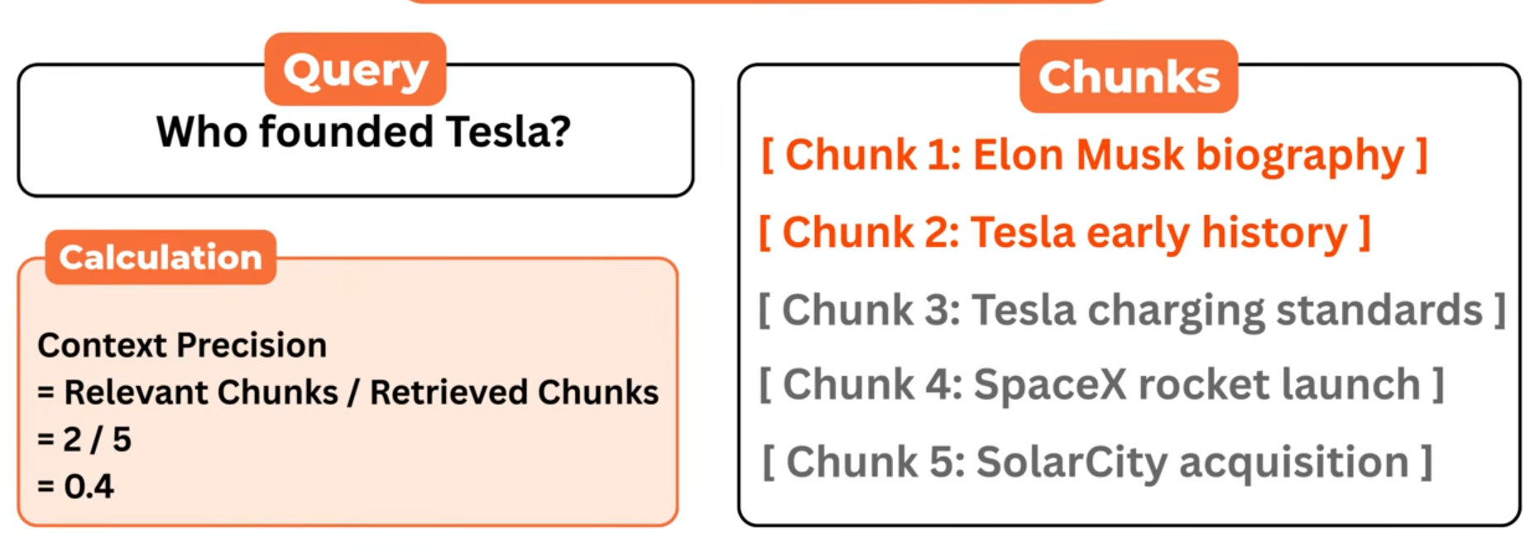

- Context Recall – It measures how much of the relevant information the retriever managed to find. Say, there are 3 important chunks in the database and out of them retriever managed to find 2 out of them so the recall is 2 out of 3.
- Answer Relevance – How directly the generated answer responds to the user question. This is usually done using embeddings.
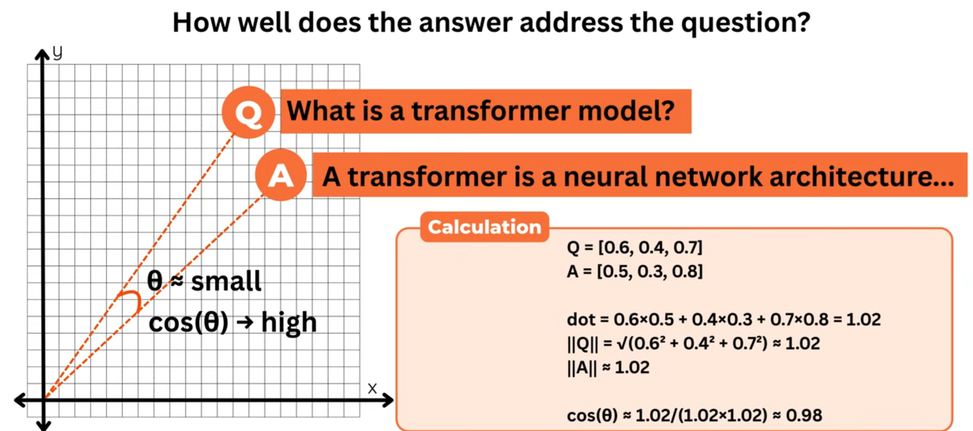

- Faithfulness – It checks whether the answer is fully supported by the retrieved context. If a statement in the answer does not appear in the retrieved text, faithfulness goes down. For example, if the retrieved context mentions Tesla’s founders and the answer adds a claim that isn’t present in those chunks, faithfulness drops because the answer is no longer grounded.
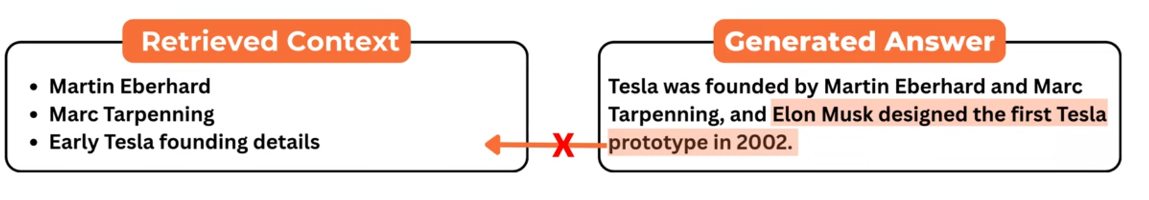
- Groundedness – It measures how well the answer uses the retrieved context, instead of relying on the models internal memory. If the answer copies or closely paraphrases relevant parts of retrieved documents Groundedness is high.
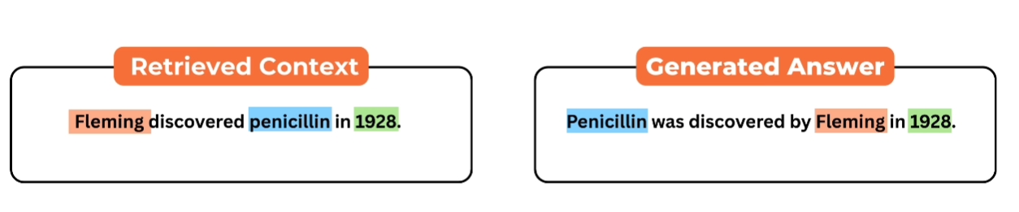groundedness is high in this case.

RAGAS is an open source framework for RAG evaluation. RAGA provides a structured way to compute rag evaluation matrix without building evaluators for each one. It uses embeddings for semantic comparisons and it uses LLM as a judge for evaluation that require deeper understanding. RAGA provides four main scores:
- Faithfulness – is the answer fully supported by the retrieved context.
- Answer Relevance – Does the answer address the question meaningfully
- Context Precision – How much of the retrieved context is relevant.
- How much of the relevant information was retrieved.

